

Properties and Structures of Materials
(Bonding)
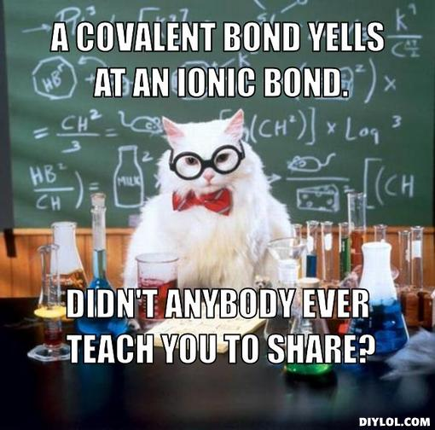
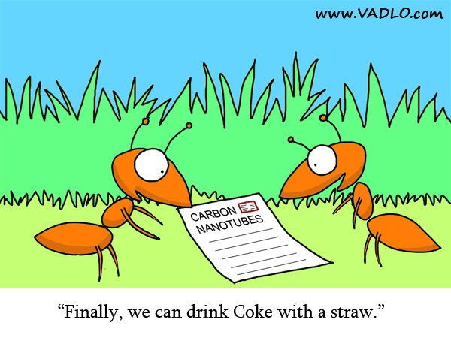

(NA 2014)

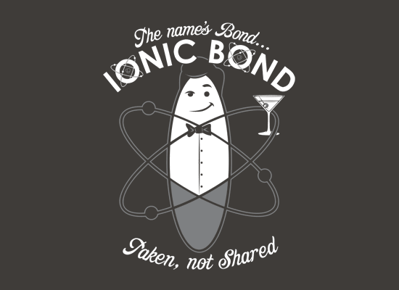
(Life in Research 2008)

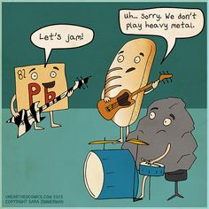

(Snorgtees nd)
(Brown nd)
Week | Outcomes | References | Tasks
6-7 | - materials are pure substances with distinct measurable properties, including melting and boiling points, reactivity, hardness and density; or mixtures with properties dependent on the identity and relative amounts of the substances that make up the mixture  - pure substances may be elements or compounds which consist of atoms of two or more elements chemically combined; the formulae of compounds indicate the relative numbers of atoms of each element in the compound  - differences in the physical properties of substances in a mixture, including particle size, solubility, density, and boiling point, can be used to separate them  - nanomaterials are substances that contain particles in the size range 1–100 nm and have specific properties relating to the size of these particles which may differ from those of the bulk material  - the type of bonding within ionic, metallic and covalent substances explains their physical properties, including melting and boiling points, conductivity of both electricity and heat and hardness  - chemical bonds are caused by electrostatic attractions that arise because of the sharing or transfer of electrons between participating atoms; the valency is a measure of the bonding capacity of an atom  - ions are atoms or groups of atoms that are electrically charged due to a loss or gain of electrons; ions are represented by formulae which include the number of constituent atoms and the charge of the ion  (for example, O^{2–}, SO₄^{2–})  - ionic bonding can be modelled as a regular arrangement of positively and negatively charged ions in a crystalline lattice with electrostatic forces of attraction between oppositely charged ions  - the ionic bonding model can be used to explain the properties of ionic compounds, including high melting point, brittleness and non-conductivity in the solid state; the ability of ionic compounds to conduct electricity when molten or in aqueous solution can be explained by the breaking of the bonds in the lattice to give mobile ions  - the formulae of ionic compounds can be determined from the charges on the relevant ions (refer to Appendix 2)  - metallic bonding can be modelled as a regular arrangement of atoms with electrostatic forces of attraction between the nuclei of these atoms and their delocalised electrons that are able to move within the three dimensional lattice  - the metallic bonding model can be used to explain the properties of metals, including malleability, thermal conductivity, generally high melting point and electrical conductivity; covalent bonding can be modelled as the sharing of pairs of electrons resulting in electrostatic forces of attraction between the shared electrons and the nuclei of adjacent atoms  - the properties of covalent network substances, including high melting point, hardness and electrical conductivity, are explained by modelling covalent networks as three-dimensional structures that comprise covalently bonded atoms  - elemental carbon exists as a range of allotropes, including graphite, diamond and fullerenes, with significantly different structures and physical properties  - the properties of covalent molecular substances, including low melting point, can be explained by their structure and the weak intermolecular forces between molecules; their non-conductivity in the solid and liquid/molten states can be explained by the absence of mobile charged particles in their molecular structure | Lucarelli p23-25 Set 4(p25) q1-8  Lucarelli p54 Set 10(p54) q1-5  Lucarelli p55 Set 11(p56) q1-6  Lucarelli p57 Set 12(p59) q1-4  Lucarelli p60 Set 13(p62) q1-6  Lucarelli p63-66 Set 14(p67) q8,11-14  STAWA Experiment 2 p13  STAWA Experiment 3 p15  STAWA Experiment 13 p36 | Task 4: Test- Properties and structure of materials: bonding

Ionic compounds
Remember, ionic compounds are formed between a metal and a non-metal and also include ammonium compounds.
- Use the ions table
- Do not use mono, di, tri tetra etc
Name | Formula
Potassium permanganate
Magnesium chloride
Aluminium chloride
Sodium nitrate
Sodium dichromate
Sodium phosphate
Calcium nitrite
Calcium nitrate
Calcium nitride
Zinc sulphite
Zinc sulphate
Zinc sulphide
Iron (II) oxide
Iron (III) oxide
Copper (I) hydroxide
Copper (II) hydroxide
Ammonium nitrate
Ammonium iodide
Ammonium sulphate
 | AgCl
 | AgCH₃COO
 | Ag₂O
 | MgO
 | Mg₃(PO₄)₂
 | SnCO₃
 | SnCl₄
 | NaHCO₃
 | Ba(CH₃COO)₂
 | Cr₂S₃
Covalent compounds
Remember covalent compounds are formed between non-metals.

- Do not use ions table
- Use mono, di, tri, tetra, penta, hexa, hepta, octa, nona, deca

Name | Formula
 | SO₂
 | SO₃
Carbon monoxide
Carbon dioxide
Trisulfur octaoxide
 | P₂F₆
 | N₂O₅
 | N₂O₃

Covalent compounds known by their common name are:

Water H₂O
Ammonia NH₃

Organic compounds like methane CH₄ are named by a system you will learn in Upper school.

Acids that you are expected to learn are:

Hydrochloric acid HCl
Ethanoic (acetic) acid CH₃COOH
Nitric acid HNO₃
Sulfurous acid H₂SO₃
Sulfuric acid H₂SO₄
Carbonic acid H₂CO₃
Phosphoric acid H₃PO₄

Nanotechnology

- What are nanoparticles?

- What is nanotechnology?

- Outline an example of a nanotechnology and its application.

- List some of the instruments used to image and manipulate nanoparticles.

Allotropes

- Define an allotrope.
______________________________________________________________________________________________________________________________________________________
Briefly discuss the following allotropes with reference to their structure and use. Include a diagram in your discussion.

Diamond

Graphite

Carbon nanotubes

Lewis diagrams
Valence electrons in an atom, molecule or ion are shown as a dot or cross (a line can be used to represent a pair of electrons but this is usually reserved for molecules or polyatomic ions).
Examples:
Atoms hydrogen atom aluminium atom bromine atom
H Al Br

Monatomic Ions sodium ion strontium ion phosphide ion iodide ion
[Na]⁺ [Sr]²⁺ [ P ]³⁻ [ I ]‒

Covalent molecules - atoms within a covalent molecule share electrons to achieve a noble gas configuration (in general this is eight electrons in the valence shell and so is called the octet rule). In sharing these electrons, the bonds formed can be single bonds (sharing two electrons), double bonds (sharing four electrons) or triple bonds (sharing six electrons).
chlorine carbon dioxide
Cl Cl O C O

Formation of ionic compound- Magnesium has two valence electrons and oxygen has six valence electrons. Oxygen gains magnesium’s two valence electrons. This produces Mg²⁺ ions and O²⁻ ions. The ions now have eight electrons in their valence shells.

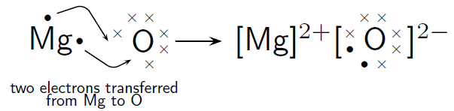

1. Metallic bonding:
The bonding between atoms within a single metal.
Definition:
Metallic bonding is the strong electrostatic attraction force between the metal cations/nuclei and the delocalized (ie mobile) valence electrons.

Diagram
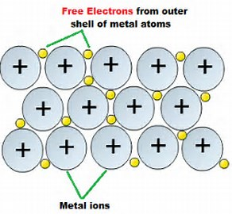 (ClipartXtras, 2017)

Examples
Iron, Aluminium, Brass

Properties
- Good conductors of electricity
Metallic substances contain delocalized valence electrons which are free to move and conduct a current.
- Relatively high melting and boiling points
The electrostatic attraction between the positive metallic ions and delocalized valence electrons in the metal is strong and it requires a lot of energy to break these bonds.
- Hardness
Strong electrostatic attraction forces between the positive metallic ions and delocalized valence electrons which requires a big force to break these bonds.
- Malleability/Ductility
Hammered into sheets or drawn out into wires. This is because as a force is applied to the metal and the positive metal nuclei are pushed closer together, the mobile valence electrons can move in between the nuclei to minimise repulsion.
- Lustre
The interaction between the incoming light and the delocalized valence electrons causes the metal to shine.
2. Ionic bonding
Between metals and non-metals (also ammonium compounds are ionic)
Definition:
Ionic bonding is the strong electrostatic attraction force between the positive cations and negative anions in an ordered, three- dimensional lattice.
The metal atom transfers electrons to the non-metal atom.(Metals lose electrons to gain a full valence shell and non-metals gain electrons to obtain a full shell). By doing so, the metal atom changes into a positive ion and the non-metal atom changes into a negative ion. This two oppositely charged ions attract each other with strong electrostatic forces to form a crystal lattice.
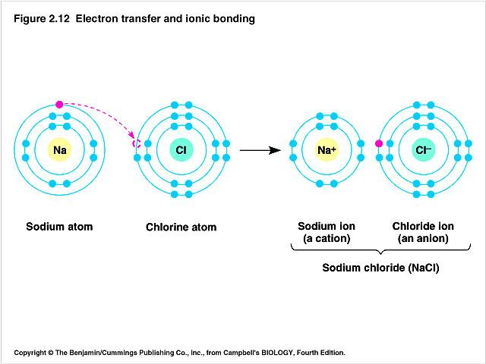
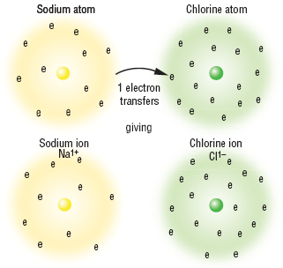

Examples NaCl, Mg(NO₃)₂

Properties
- Conductivity
Do not conduct in the solid state because the ions are held in fixed positions in the lattice and are therefore not able to move in order to conduct a current.
In the molten state or in solution the ions separate from the lattice and become free to move and so can conduct a current.
- Melting point and boiling points
High because of the strong electrostatic attraction force between the oppositely charged ions in the lattice which requires a lot of energy to break these bonds in order to separate the ions.
- Brittle
In the lattice the particles are packed in fixed positions. Applying a force will force same charged particles together and they will repel each other. These forces of repulsion will shatter the structure.
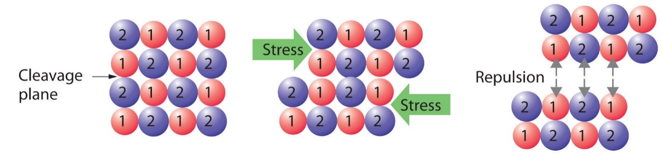
3. Covalent bonding
Between non-metals
Definition:
Covalent bonding is due to the strong electrostatic attraction between the shared valence electrons and the positive nuclei of the atoms involved in the bond. This can occur to form molecules or networks.
Both non-metals want to gain electrons to fill their outer shell. Electron sharing takes place between the two atoms to fill both their outer shells with 8 electrons.
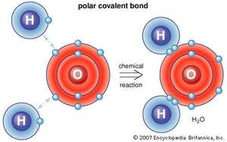
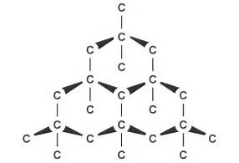

Covalent bonds between hydrogen and oxygen in water molecule Covalent bonds between carbon atoms in diamond network
Examples
Covalent molecular: CO₂, H₂O, NH₃, C₈H₁₈
Covalent network: SiC, diamond, SiO₂
Properties of covalent molecular substances
1.Conductivity
Do not conduct in any state. All electrons are held tightly in bonds and so there are no free moving electrons to conduct a current.
2. Melting pointing and boiling points
Low (usually gases and some liquids at room temperature) because there are weak intermolecular forces between the molecules which doesn’t require a lot of energy to overcome in order to separate the molecules.
3.Hardness
Soft because the weak intermolecular forces between the molecules doesn’t require a big force to overcome in order to separate the molecules.

Properties of covalent network substances

1. Conductivity
Do not conduct in any state. All electrons are held tightly in bonds and so there are no free moving electrons to conduct a current.
2. Melting and boiling points
Very high because multiple strong covalent bonds between atoms in the network have to be broken which requires a lot of energy.
3. Hardness
Very hard because multiple strong covalent bonds between atoms in the network have to be broken which requires a large force.
4. Brittle
A force can disrupt the lattice

- Melting and Boiling Points
a) Why do metallic compounds have high melting and boiling points?
The electrostatic attraction between the positive metallic ions and delocalized valence electrons in the metal is strong and it requires a lot of energy to break these bonds.
b) Why do ionic compounds have high melting points?
The electrostatic attraction between the oppositely charged ions in the lattice is strong and it requires a lot of energy to separate the ions.
c) Why do covalent molecular substances have low melting and boiling points?
The attraction between the molecules is weak (the intermolecular force is weak) and it does not require a lot of energy to separate the molecules.
d) Why do covalent network substances have high melting and boiling points?
The atoms in a covalent network substance are strongly covalently bonded in a giant network so multiple strong covalent bonds need to be broken in order for the substance to melt or boil and this will therefore require a lot of energy.

- Electrical conductivity
a) Why are metallic substances good conductors of electricity?
Metallic substances contain delocalized valence electrons which are free to move and conduct a current.
b) Why can ionic substances conduct electricity when they are molten (melted) or dissolved in water (in solution) but not when they are solid?
In the solid form the ions in the ionic compound are held in fixed positions in the lattice and are therefore not able to move in order to conduct a current. When the ionic compound is melted or dissolved, however, the ions separate from the lattice and become free to move and so can conduct a current.
c) Why do covalent molecular substances not conduct electricity in any form?
All electrons in covalent molecular substances are held tightly in bonds and there are therefore no electrons that are free to move and conduct a current. The molecules are also not charged species so they cannot carry charge and conduct a current.
d) Why do covalent network substances not conduct electricity in any form?
All electrons in covalent network substances are held tightly in bonds and there are therefore no electrons that are free to move and conduct a current.

- Explain why metals can be beaten into shape but ionic compounds are crystalline and shatter into pieces when beaten.
- When metals are beaten, the delocalized valence electrons are able to move in between the positive metallic nuclei and minimise repulsion.
- When ionic compounds are beaten the ions of the same charge will be forced together and they will repel each other. This will cause the crystal to break/ shatter.
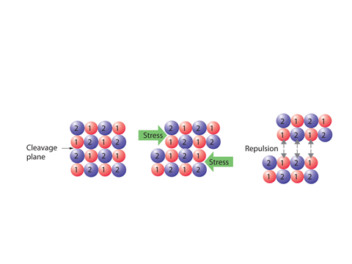

Bibliography
Brown, J. "Science." Pintrest. nd. https://www.pinterest.com/julsb98/science/ (accessed February 26, 2015).
Life in Research. "Life in Research Cartoon #21." Vadlo Life Sciences Search Engine. 2008. http://vadlo.com/cartoons.php?id=21 (accessed February 26, 2015).
NA. "Chemsirty Cat Meme Generator." Pics & photos. 2014. http://funny-pictures.picphotos.net/chemistry-cat-meme-generator-diy-lol510/assets.diylol.com*hfs*6f8*5a9*51e*resized*chemistry-cat-meme-generator-a-covalent-bond-yells-at-an-ionic-bond-didn-t-anybody-ever-teach-you-to-share-3ad3fd.jpg/ (accessed February 26, 2015).
Snorgtees. "The NAme's Bond, Ionic Bond." Snorg Tees. nd. http://www.snorgtees.com/the-name-s-bond-ionic-bond (accessed February 26, 2015).
Davis, A. Nelson Chemistry Units 1 & 2. South Melbourne: Cengage Learning Australia Pty Limited, 2014.
Lucarelli, N. ESSENTIAL CHEMISTRY Australian Curriculum for WA ATAR Chemistry Units 1 + 2. Willetton: Lucas Publications, 2014
Clark, J and Baddock, M Exploring Chemistry Year 11 Experiments, Investigations and Problems Osborne Park STAWA, 2014.

ClipartXtras. (2017). 28 Collections of Metallic Bonding Drawings.
edspeaksny. (2012, May 28th). Kids Speak: Chemistry Can be Cool. Retrieved from Education Speaks: http://educationspeaks.org/2012/05/kids-speak-chemistry-can-be-cool/
NA. (2013). Johnny Was A Chemist's Son. Retrieved from Pickycovers: http://www.pickycovers.com/cover/742/johnny-was-a-chemists-son

